COMSAT-C WEB INTERFACE

Topic | See Page
Launching the web service interface | 1
SafetyNet Message Procedure | 3
Shore to Ship Distress Alerts | 4
Search and Rescue Messages | 6
Navigational Warning Messages | 9
Compose Message | 11
Delivery Status | 13
Read Mail | 16
Monitoring Messages | 18
Canceling Messages | 21
Sending a cancel notification | 23
User Profile | 24
Error Messages | 25

Launching the web service interface. | Follow the steps below to launch and log-in to the COMSAT INMARSAT-C Web Interface. These steps will bring you to the COMSAT-C Main Page.

Step | Action
1 | Open Internet Explorer, type in www.c-link.com, press Enter or Go.
2 | You will receive the following security alert . Press Ok.  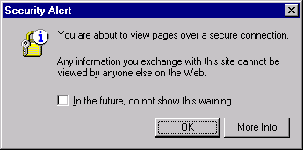
3 | The following log-in screen will appear. Type in your User Name and Password. Select Extra Security. Press Login.  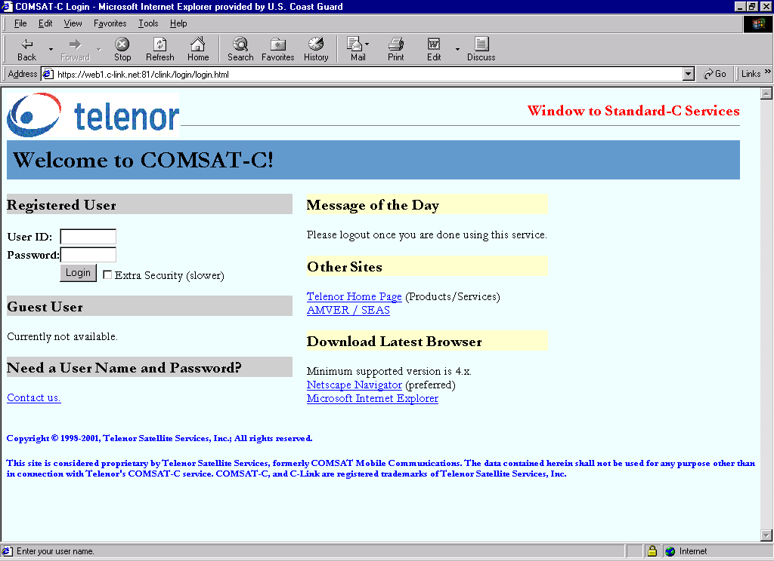
4 | The Main page will appear. Click on the menu items on the left to send broadcasts, read mail, check delivery status, change your user profile, ... Detailed steps for these options are in the following sections.  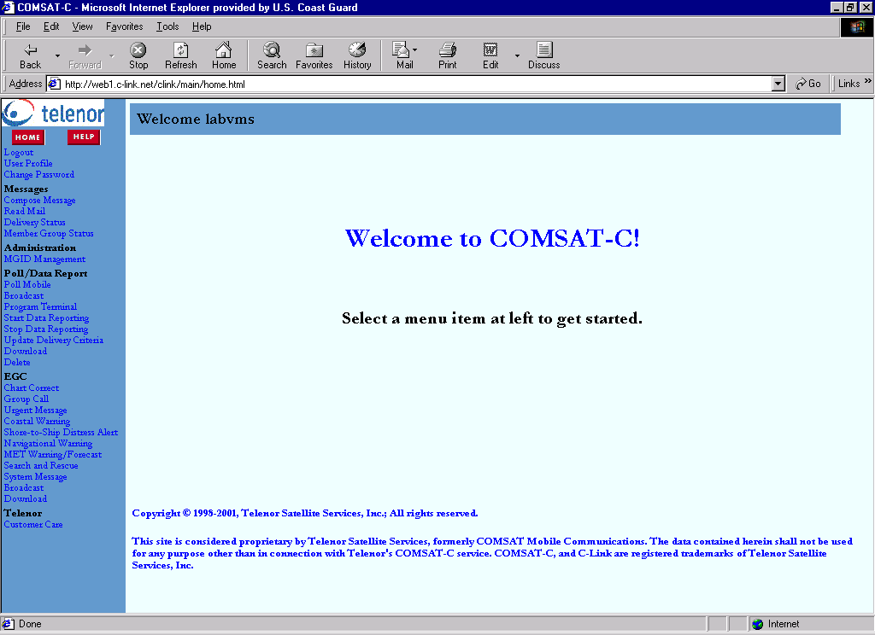

SafetyNet Message Procedure | The following steps should be followed for each situation requiring an INMARSAT-C SafetyNet broadcast, per Chapter 2 of the CG Addendum to the National SAR Manual. Details on completing each step are covered in separate sections.

Step | Action
1 | Select the appropriate message type based on the emergency phase of the case and the addressing region. The table below is an excerpt from the table in section 2.3.6 of the CG Addendum to the National SAR Manual.
  Emergency Phase | Web form(s) | Priority | Addressing
  Uncertainty | Search and Rescue | Safety | Circular  Rectangular
   | Navigational Warning | Safety | NAVAREA
  Alert | Search and Rescue | Urgent | Circular
   | Navigational Warning | Urgent | NAVAREA
  Distress | Shore to Ship Distress | Distress | Circular
   | Search and Rescue | Distress | Rectangular
2 | Draft and send the message.
3 | Check the Delivery Status for status of your message. Save the Message to the case file.
4 | Check your inbox for a receipt and save the receipt to the case file.  Note: Receipt of broadcasts confirm the LES has received your message and has forwarded it for broadcast over the satellites. Receipt of composed messages confirm an individual terminal has received the message.
5 | Ensure monitored copy of message arrives. Compare monitored copy to original message.

Shore to Ship Distress Alerts | Follow the steps below to send a distress alert to a circular region.
 |  | Step | Action
 |  | 1 | Click on “Shore to Ship Distress Alert” under the EGC Section to open the following Shore to Ship Distress Alert form:  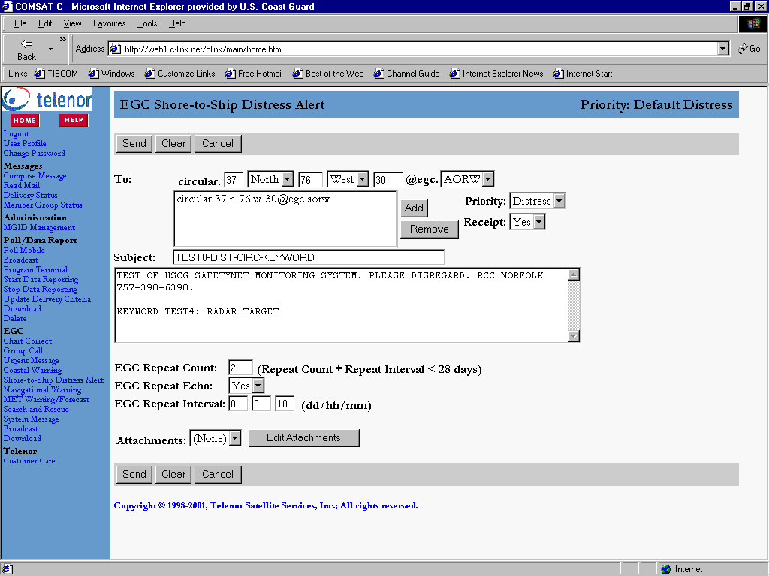
 |  | 2 | Address the message:  Along the top line fill in the:  Latitude, select North or South  Longitude, select East or West  Radius of broadcast around the given position (NM).  Select which satellite the message will be broadcast over (AOR-W, AOR-E, POR, IOR)  Click Add.
 |  | 3 | Repeat step 2 for each satellite footprint (ocean region) the message must be broadcast to. If a position is within two satellite regions the message must be addressed to both regions for broadcast. This most often occurs with positions in the AOR-E and AOR-W regions.
 |  | 4 | Ensure “Distress” is selected under the Priority drop down box. Always send the Distress Message type with Distress priority!
 |  | 5 | Ensure “Yes” is selected under the Receipt drop down box. If you do not select “Yes”, you will not get a receipt in the inbox after the message has been broadcast. (No charges incurred for broadcast receipt.)
 |  | 6 | Type in a subject. This subject will not appear in the broadcast message but can be used to find messages in the delivery status table.
 |  | 7 | Type in the body of the message.  Ensure your RCC name is included in the message body for forwarding of monitored copies of your messages.
 |  | 8 | Enter the Repeat Count – the total number of times the message is sent. (not including the echo.)  Enter the Repeat Interval – the time interval between each of the repeat broadcasts.  Repeat Count*Repeat Interval = the total time from first broadcast to last.  I.e. If the count = 4 and interval = 6 hrs, the message is broadcast 4 times, every 6 hours, for a total time of 24 hours from first to last broadcast.
 |  | 9 | Ensure Repeat Echo is set to “Yes” – Repeat Echo indicates whether the system is to retransmit the EGC message six minutes after each scheduled broadcast. Since a vessel that is broadcasting a message cannot receive messages, and since most broadcasts are less than 6 minutes, the echo option ensures a message is received.
 |  | 10 | Ensure “None” is selected under the attachments drop down box.
 |  | 11 | Review for accuracy and press send. *This step very important since messages usually pass through the system within seconds. You may not have time to cancel a message prior to the initial broadcast being made.
 |  | 12 | After you press send, the form clears and the MRN is given along the top of screen. Record the MRN number  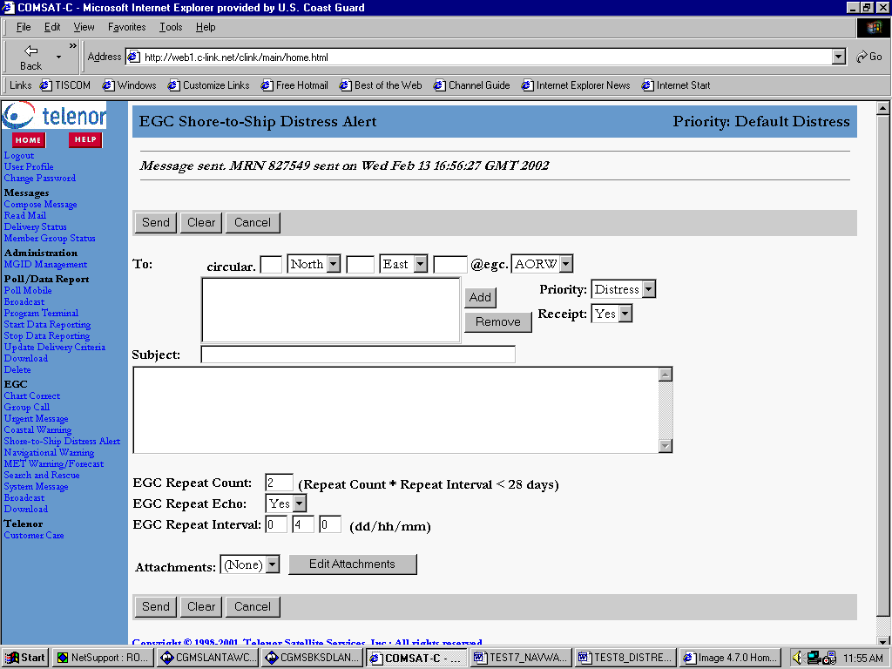

Search and Rescue Messages | Follow the steps below to send a search and rescue message to a rectangular or circular region.

Step | Action
1 | Click on “Search and Rescue” under the EGC Section to open the following Search and Rescue Message form:  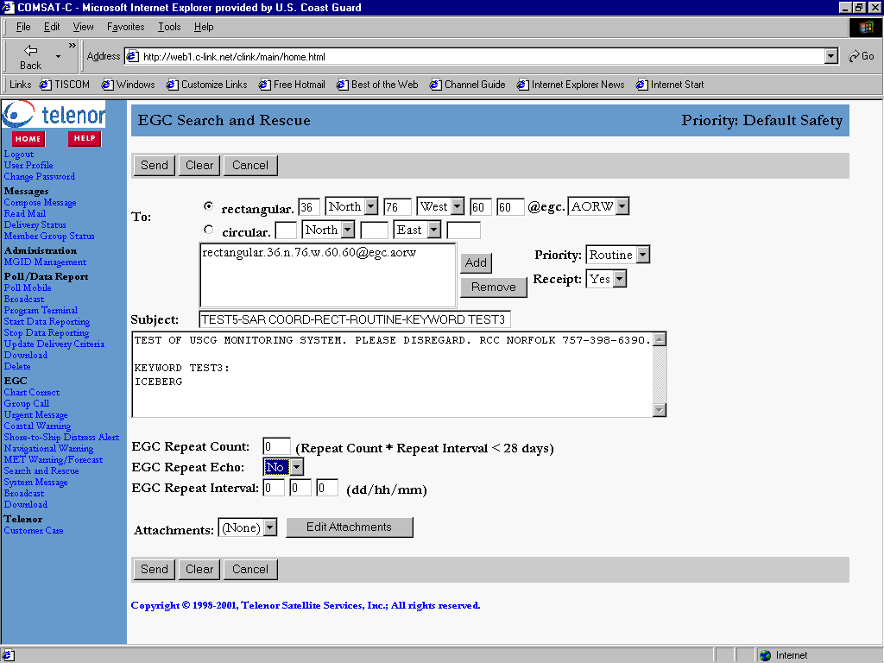
2 | Address the message:  For Rectangular Areas fill in the:  Latitude, select North or South  Longitude, select East or West  Latitudinal Extension (degrees)  Longitudinal Extension (degrees)  Select which satellite the message will be broadcast over (AOR-W, AOR-E, POR, IOR)  Click Add.  *Note: The position entered is the southwest corner of the rectangular broadcast area.  For Circular broadcasts fill in the:  Latitude, select North or South  Longitude, select East or West  Radius of broadcast around the given position. (NM)  Select which satellite the message will be broadcast over (AOR-W, AOR-E, POR, IOR)  Click Add.
3 | Repeat step 2 for each satellite footprint (ocean region) the message must be broadcast to. If a position is within two satellite regions the message must be addressed to both regions for broadcast. This most often occurs with positions in the AOR-E and AOR-W regions.
4 | Select the Priority.
5 | Ensure “Yes” is selected under the Receipt drop down box. If you do not select “Yes”, you will not get a receipt in the inbox after the message has been broadcast. (No charges incurred for broadcast receipt.)
6 | Type in a subject. This subject will not appear in the broadcast message but can be used to find messages in the delivery status table.
7 | Type in the body of the message.  Ensure your RCC name is included in the message body for forwarding of messages once they are received over a CG receiver at the CAMS.
8 | Enter the Repeat Count – the total number of times the message is sent. (not including the echo.)  Enter the Repeat Interval – the time interval between each of the repeat broadcasts.  Repeat Count*Repeat Interval = the total time from first broadcast to last.  I.e. If the count = 4 and interval = 6 hrs, the message is broadcast 4 times, every 6 hours, for a total time of 24 hours from first to last broadcast.
9 | Ensure Repeat Echo is set to “Yes” – Repeat Echo indicates whether the system is to retransmit the EGC message six minutes after each scheduled broadcast. Since a vessel that is broadcasting a message cannot receive messages, and since most broadcasts are less than 6 minutes, the echo option ensures a message is received.
10 | Ensure “None” is selected under the attachments drop down box
11 | Review for accuracy and press send. *This step very important since messages usually pass through the system within seconds. You may not have time to cancel a message prior to the initial broadcast being made.
12 | After you press send, the form clears and the MRN is given along the top of screen. Record the MRN number  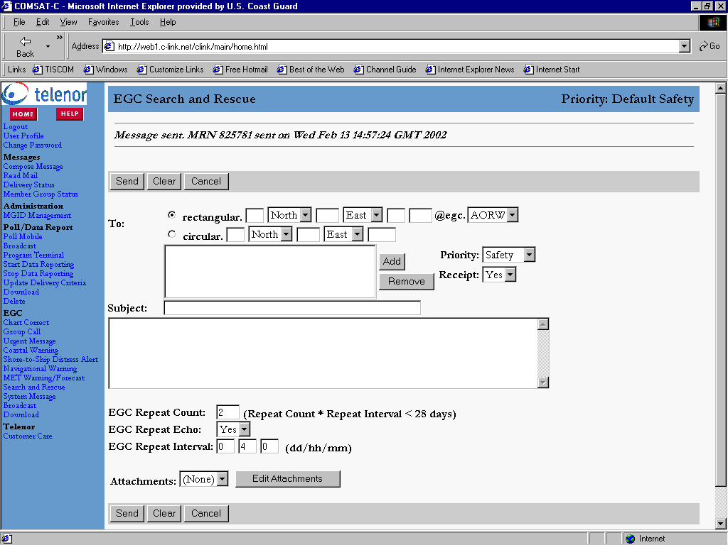

Navigational Warning Messages | Follow the steps below to send a message to a NAVAREA.
 |  | Step | Action
 |  | 1 | Click on “Navigational Warning” under the EGC Section to open the following Navigational Warning Message form:  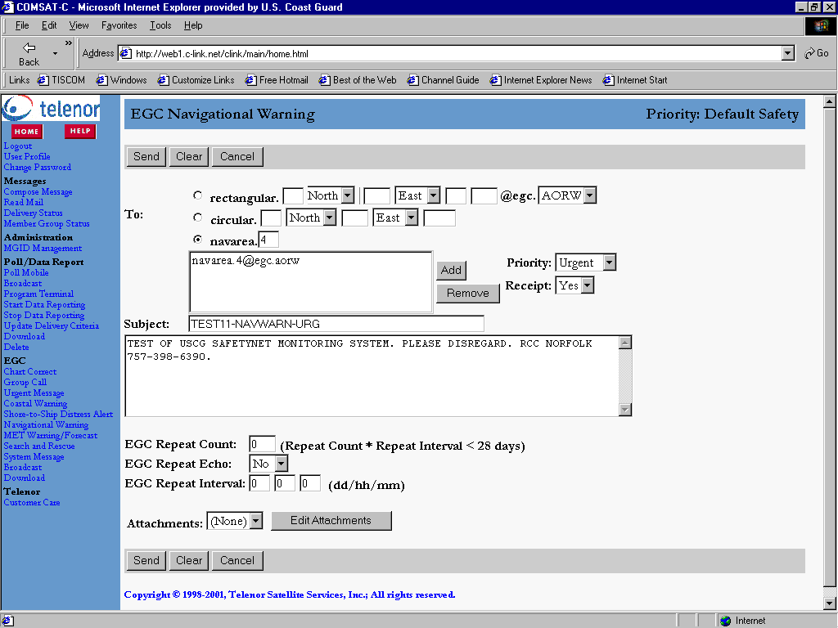
 |  | 2 | Address the message:  Select the circle next to ‘navarea’. Enter the Navarea as a number. i.e. 4 for Northern Atlantic.  Select which satellite the message will be broadcast over (AOR-W, AOR-E, POR, IOR)  Click Add.
 |  | 3 | Repeat step 2 for each satellite footprint (ocean region) the message must be broadcast to. If a position is within two satellite regions the message must be addressed to both regions for broadcast. This most often occurs with positions in the AOR-E and AOR-W regions.
 |  | 4 | Select the Priority.
 |  | 5 | Ensure “Yes” is selected under the Receipt drop down box. If you do not select “Yes”, you will not get a receipt in the inbox after the message has been broadcast. (No charges incurred for broadcast receipt.)
 |  | 6 | Type in a subject. This subject will not appear in the broadcast message but can be used to find messages in the delivery status table.
 |  | 7 | Type in the body of the message.  Ensure your RCC name is included in the message body for forwarding of messages once they are received over a CG receiver at the CAMS.
 |  | 8 | Enter the Repeat Count – the total number of times the message is sent. (not including the echo.)  Enter the Repeat Interval – the time interval between each of the repeat broadcasts.  Repeat Count*Repeat Interval = the total time from first broadcast to last.  I.e. If the count = 4 and interval = 6 hrs, the message is broadcast 4 times, every 6 hours, for a total time of 24 hours from frist to last broadcast.
 |  | 9 | Ensure Repeat Echo is set to “Yes” – Repeat Echo indicates whether the system is to retransmit the EGC message six minutes after each scheduled broadcast. Since a vessel that is broadcasting a message cannot receive messages, and since most broadcasts are less than 6 minutes, the echo option ensures a message is received.
 |  | 10 | Ensure “None” is selected under the attachments drop down box
 |  | 11 | Review for accuracy and press send. *This step very important since messages usually pass through the system within seconds. You may not have time to cancel a message prior to the initial broadcast being made.
 |  | 12 | After you press send, the form clears and the MRN is given along the top of screen. Record the MRN number  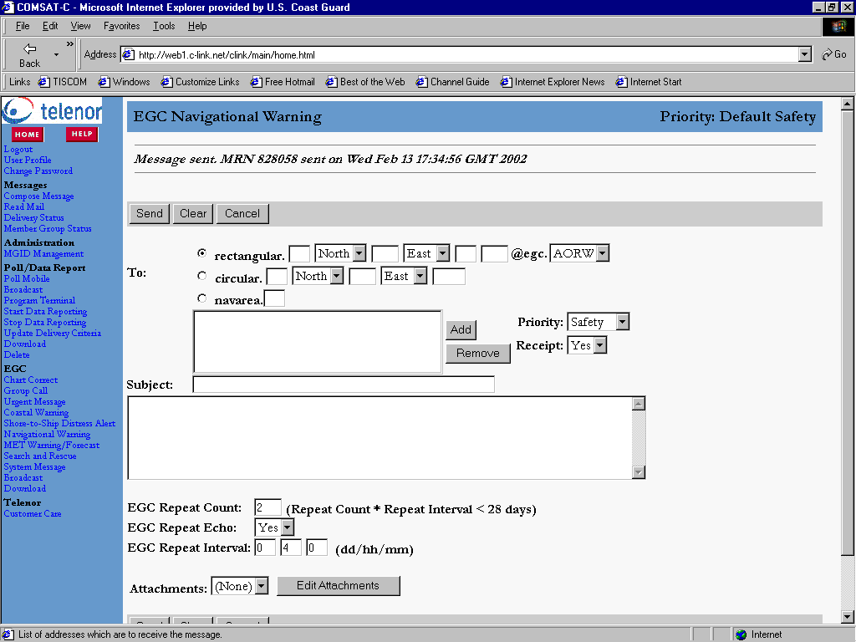

Compose Message | Follow the steps below to send a message directly to a vessel.

Step | Action
1 | Click on “Compose Message” under the Messages Section to open the following Compose Message form:  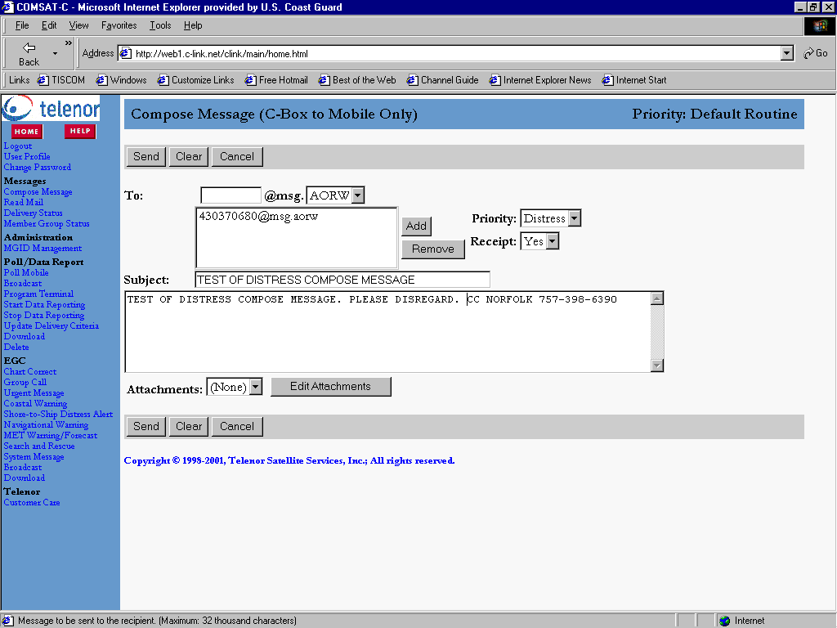
2 | Address the message with the INM-C number to the ocean region Best. The “Best” ocean region option will send the message to the satellite the terminal was last logged onto. If you know the vessel to be in a certain region you can address the message to the know satellite for that region instead.
3 | Select Priority.
4 | Ensure “Yes” is selected under the Receipt drop down box. This receipt will confirm that the vessel actually received the message. If you do not select “Yes”, you will not get a receipt in the inbox after the message has been broadcast. A minimal charge will be incurred for this receipt.
5 | Type in a subject. This subject will not appear in the broadcast message but can be used to find messages in the delivery status table.
6 | Type in the body of the message.
7 | Ensure “None” is selected under the attachments drop down box.
8 | Review for accuracy and press send.
9 | After you press send, the form clears and the MRN is given along the top of screen. Record the MRN number  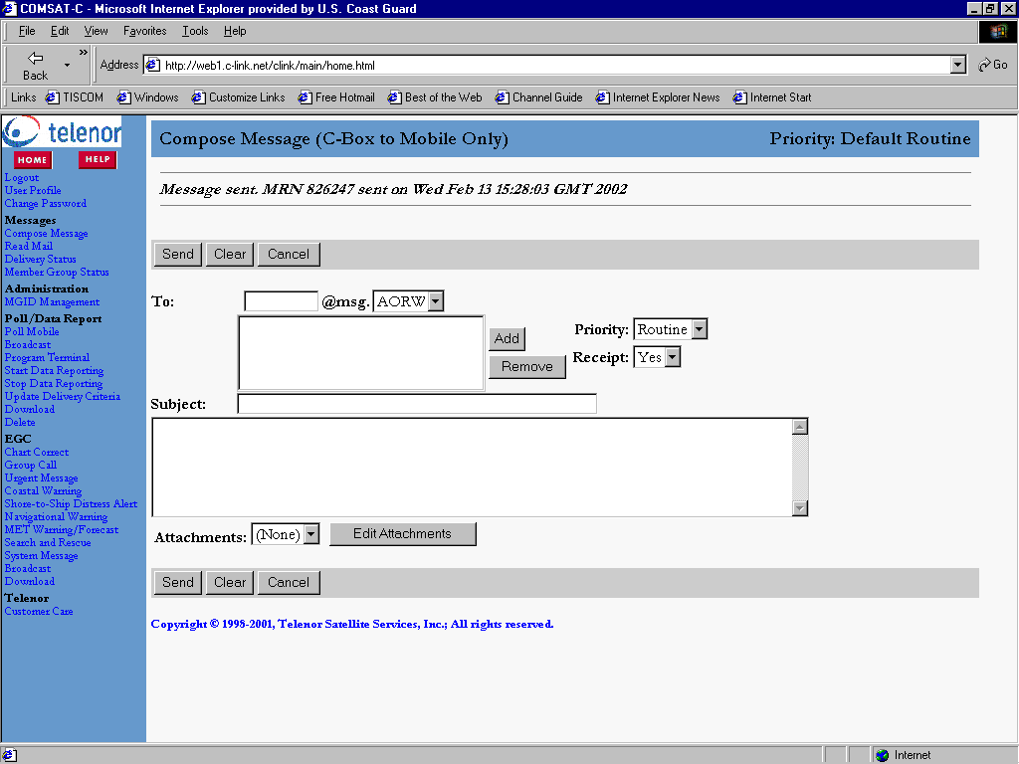

Delivery Status | Follow the steps below to check the status, view, and save your message.

Step | Action
1 | Click on “Delivery Status” under the Messages Section to open the status table:  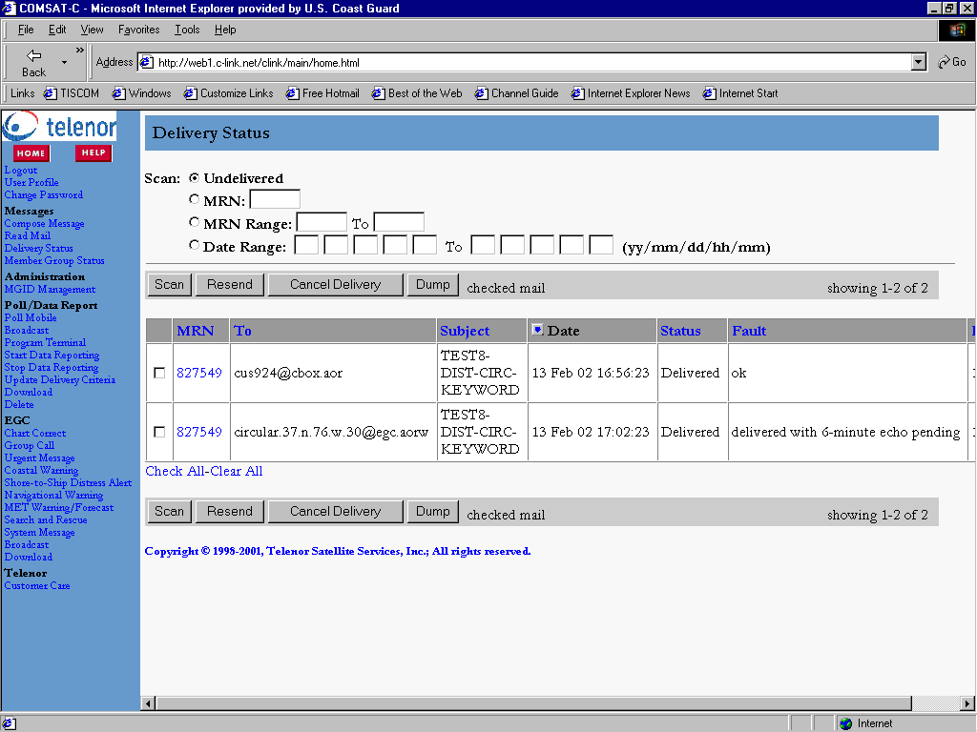
2 | Check for your MRN number by typing the number into the box next to “MRN”, select the circle next to MRN, and press SCAN. You can also type in date ranges or MRN ranges and press SCAN. The MRN(s) for those dates or MRN numbers will appear on the screen.
3 | Verify status under Status Column. (failed, delivered, cancelled, in progress). The following are potential status categories and what they mean. If status is ‘failed’, check Fault tables for cause of failure, fix the problem causing the failure, and resend. If delivered, proceed to step 4.  Status: Delivered  Fault: ok  Description: All copies (including all repeats) have been forwarded for broadcast)  Status: In progress  Fault: Delivered with repeat pending  Description: The message was broadcast the number of times indicated in the Retires column and repeat broadcast(s) are pending.  Status: In progress  Fault: Absent  Description: Delivery attempted but the terminal was not logged into the satellite the message was addressed to. This Status will remain until 3 retries have been completed  Status: Failed  Fault: See fault tables  Description: See fault tables  Status: Cancelled  Fault: Message transfer cancelled  Description: The broadcast of the message was cancelled manually.
4 | Open MRN message by clicking on the MRN number once. Verify message is the same as what you submitted. If the message matches what was sent, proceed to step 5. If the message has an error, cancel the message, draft a new message, and press Send. (The text does not wrap around in the Internet Explorer viewer. To see wrapped text, open your saved message in word.)  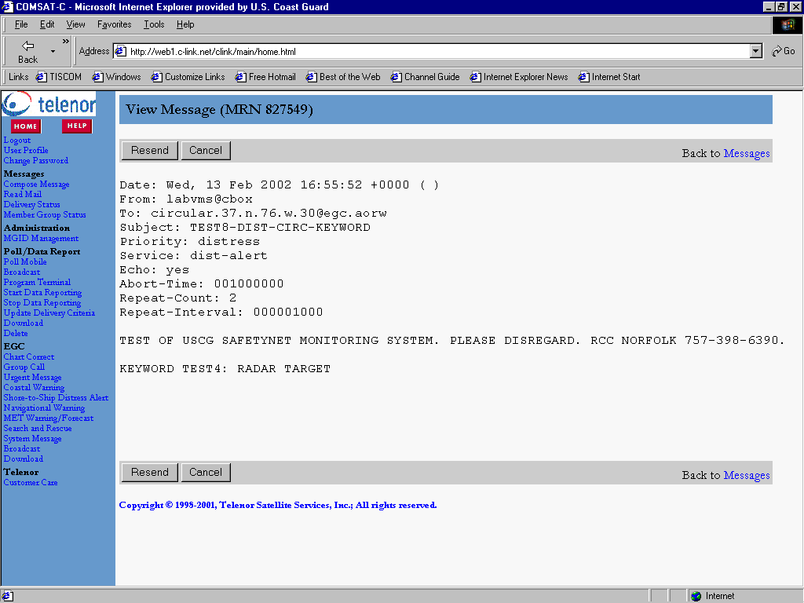
5 | Save the Message from the Delivery Status table (view table by clicking “Delivery Status” or the Back arrow button to get the previous screen.). Right click on the MRN number and select “Save As”. Save to an electronic case file designated by your command center.

Read Mail | Follow the steps below to read mail. Mail consists of messages sent to your cbox from another cbox and receipts from messages sent.

Step | Action
1 | Click on “Read Mail” under the Messages Section to open your inbox:  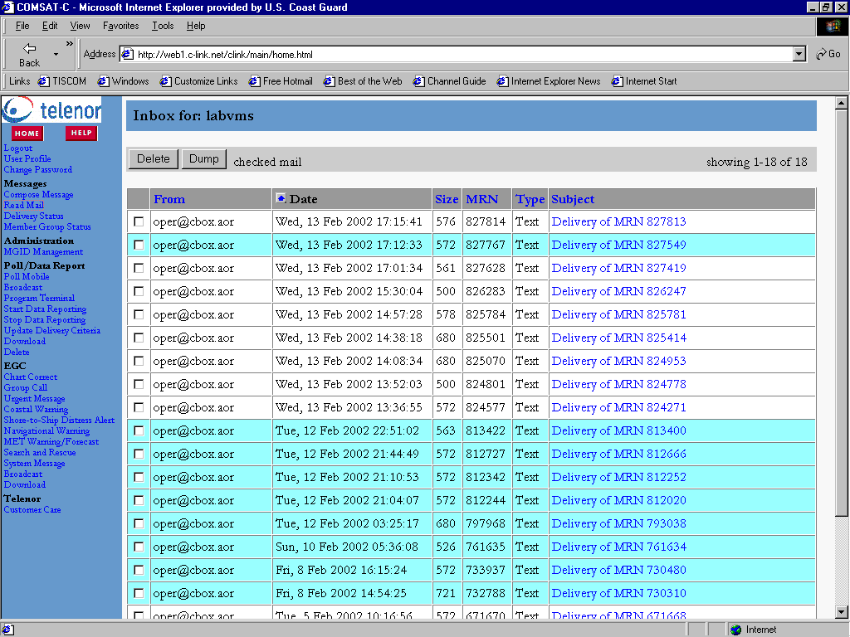
2 | Receipts are displayed with a subject: “Delivery of MRN”. Open the receipt by clicking on the subject. Review the receipt to ensure your message was received by COMSAT and forwarded for broadcast. The receipt will not be sent to the inbox until ALL repeats have been forwarded.  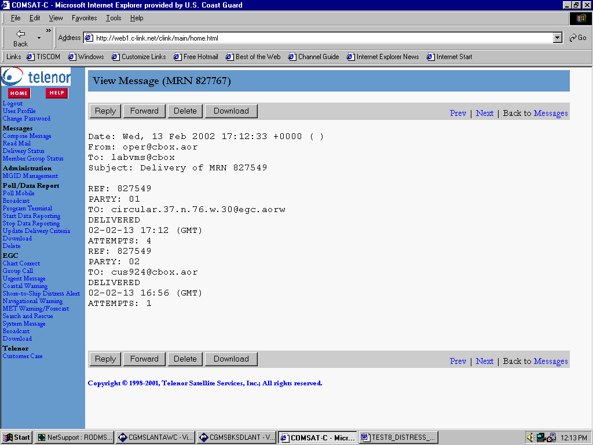
3 | Save the Receipt from the Inbox window. (view inbox by clicking “Read Mail” or the Back arrow button to get the previous screen). Right click on the subject and select Save As. Save the receipt to an electronic case file designated by your command center.

Monitoring Messages | Follow the steps below to monitor the broadcast message.

Step | Action
1 | Wait for message to be forwarded via CGMS from the respective CAMS site. In general, messages should be received within 30 minutes of broadcast. If message arrives, proceed to step 2, if not, proceed to step 5.
2 | Compare the information between the “QUOTE” and “UNQUOTE” on the monitored message, to the original message obtained from the delivery status window.  The example message shown below is the monitored copy of the message drafted in the Search and Rescue Messages Section above. The parts of the message are explained below.  R 131457Z FEB 02 ZUI ASN-ACC044000045  FM COGARD CAMSLANT CHESAPEAKE VA//EGC//  TO COMINTICEPAT GROTON CT  COMLANTAREA COGARD PORTSMOUTH VA//ACC//  BT  UNCLAS  SUBJ: MSG 8 (Rep: 0) SAR COORDINATION  QUOTE  13-14:57 044 6234 EGC  LES 1 - MSG 8 - SAR Routine Call to Area: 36+60 N 76+60 W - Rep# 0  TEST OF USCG MONITORING SYSTEM. PLEASE DISREGARD. RCC NORFOLK  757-398-6390.  KEYWORD TEST3:  ICEBERG  UNQUOTE  BT  NNNN
2  cont’d | R 131457Z FEB 02 ZUI ASN-ACC044000045  CGMS Message precedence will be set based on priority of the SafetyNET Message:  Distress – Flash (Z)  Urgent – Immediate (O)  Safety – Priority(P)  Routine – Routine (R)  The time is set by the CGMS Switch. It is not necessarily the same as the time the message was received on the receiver.  FM COGARD CAMSLANT CHESAPEAKE VA//EGC//  CGMS messages will always be from the backside circuits at CAMSLANT or CAMSPAC.  TO COMINTICEPAT GROTON CT  COMLANTAREA COGARD PORTSMOUTH VA//ACC//  CGMS messages will be addressed to units whose keywords appear in the text of the message.  SUBJ: MSG 8 (Rep: 0) SAR COORDINATION  The CGMS Message Subject includes the Message ID, Repetition number and Service Type.  QUOTE…UNQUOTE  The message as received on the Thrane and Thrane manufactured is placed within “QUOTE” and “UNQUOTE” in the CGMS message. The receiver places a header on the message. The header is explained in the table below. The service type, priority, and position should be the same as those on the original message from the web site. The text displayed after the header should be identical to the text typed into the text box on the web site.  Header explanation:
  13-14:57 | Day – hour:minute
  044 6234 | LES ID number (ignore)
  EGC LES 1 | LED ID (ignore)
  MSG 8 | Message ID number. (Not the same as MRN from website).
  SAR | Service Type
  Routine Call to Area | Priority
  36+60 N 76+60 W | Position
  Rep# 0 | Repetition number of broadcast.  I.e. This is first message broadcast or 0th ‘repetition’.  Echo messages will show same Rep number.
3 | A monitored copy of the message should be received for every original broadcast, Echo, and repeat broadcast of the message.
4 | If a message is broadcast more times than requested, cancel the message. If the message was not broadcast as long as needed, contact customer care and redraft the message if needed.
5 | If a monitored copy of the message is not received within 30 minutes, contact the respective CAMS. Check if:  - The monitor is up and running,  - The message is in the CAMS CGMS log. (provide keyword information to CAMS to perform search of archived files)  If the monitoring system appears to be running correctly, contact Customer Care to verify that the web system is functional.

Canceling Messages | Follow the steps below to cancel a message. Messages can be cancelled while in progress for broadcast or while waiting for a repeat broadcast. Messages that have already been broadcast cannot be cancelled (recalled).

Step | Action
1 | Click on “Delivery Status” under the Messages Section to open the status table:  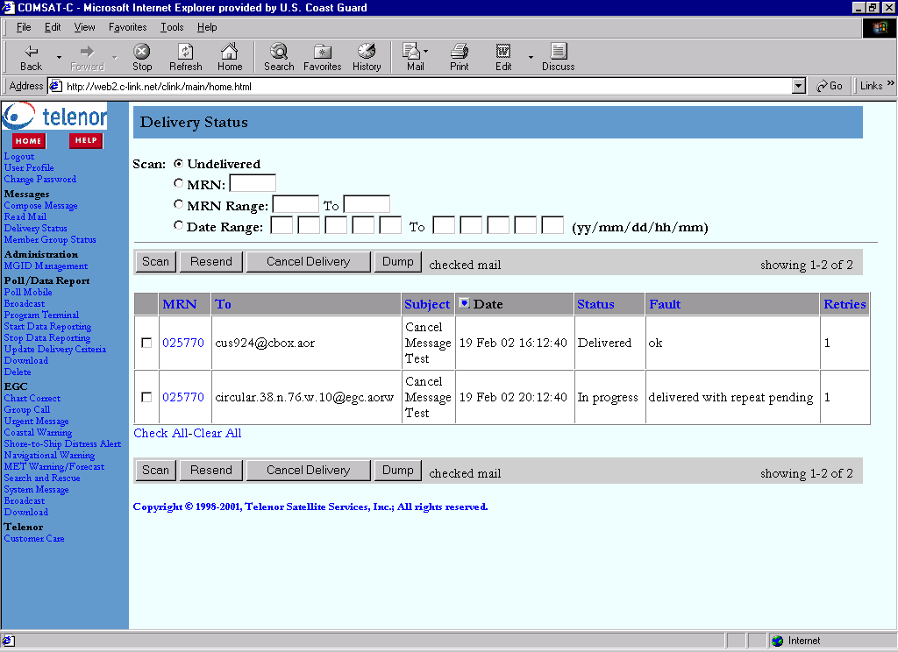
2 | Check for your MRN number by typing the number into the box next to “MRN”, select the circle next to MRN, and press SCAN. You can also type in date ranges or MRN ranges and press SCAN. The MRN(s) for those dates or MRN numbers will appear on the screen.
3 | Click the box next to the MRN number of the message you want to cancel. Press “Cancel Delivery”. A dialog box asking “Do you want to cancel the message(s)?” will appear. Press Ok.  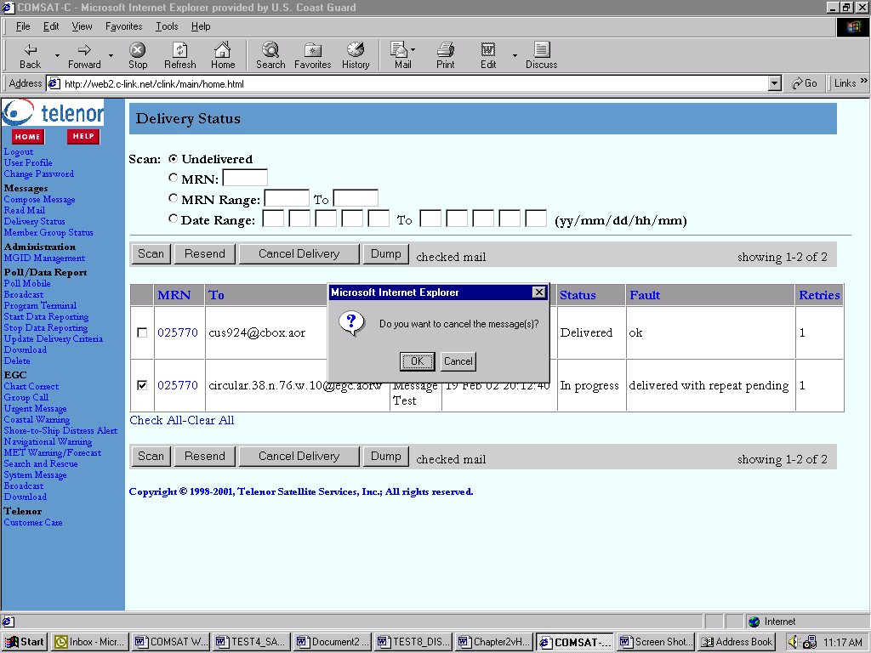
4 | After you press the cancel delivery button and ok in the dialog box, “Message cancelled” with the MRN number is displayed along the top of the screen. 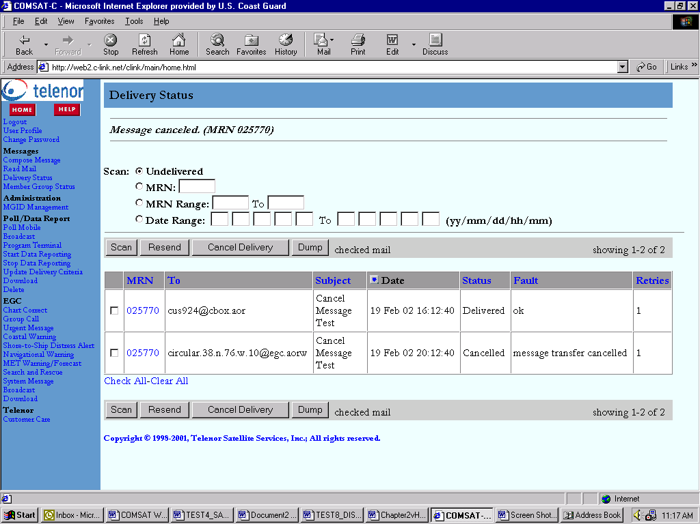
5 | For pending broadcast messages, such as an urgent or distress, that have gone out once(or several times) and are queued for repeat broadcast, the delivery status screen will show “message transfer cancelled.”  If the message was already broadcast and not scheduled to be broadcast again(as with the message to cus924), the Status will still say “Status Delivered” and Fault “ok”. Since the message was already broadcast, it will not be cancelled. (Messages cannot be recalled)
6 | After the message is cancelled, the receipt is sent to the inbox. The receipt will indicate that the entire broadcast was cancelled even if the original message, and some of the repeats, have been broadcast.  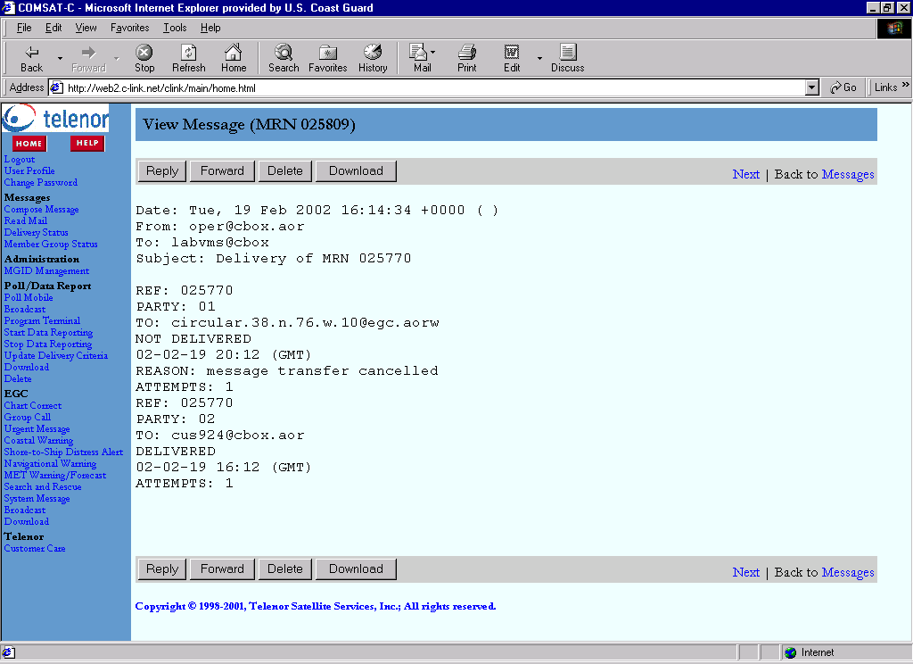

Sending a cancel notification | Canceling a message per the “Canceling Messages” steps does not notify mariners that a case has closed or that requested information is no longer needed (i.e. rescue in progress).  If an RCC chooses to broadcast a message notifying mariners that a case has closed, the cancel notification should:  - Be sent using the same message form and priority as the original broadcast.  - Reference the MSG number shown on the monitored copy of the message. (The MRN received from the web is not broadcast to the mariners.)

User Profile | Changes can be made to user defaults through the User profile. Follow the steps below to change User Profile settings.

Step | Action
1 | Click on User Profile in the menu on the left of the screen to open the User Profile . 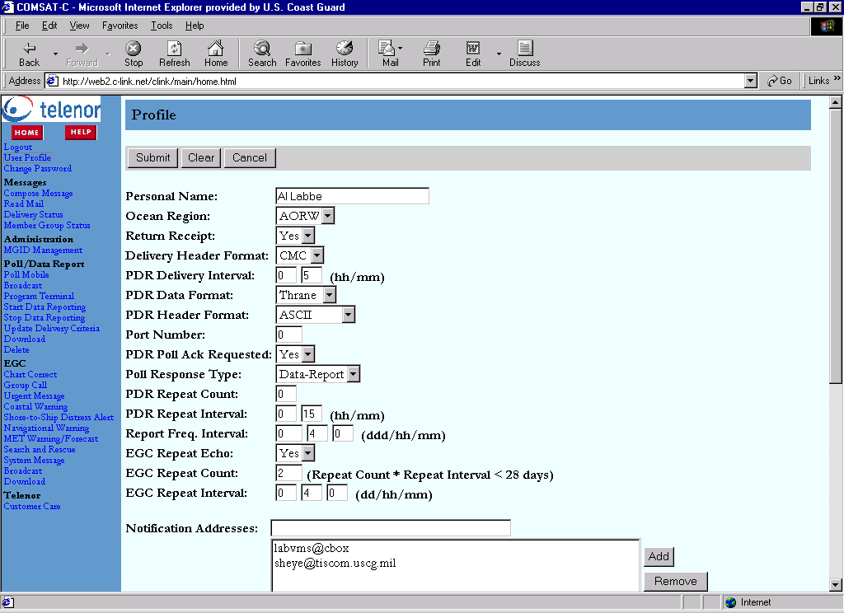
2 | Changes can be made using the drop down boxes or typing in the fields and clicking add as appropriate.  See the Help section on the web for information on User Profile fields and options.
3 | After all desired changes are made, click Submit. To go back to the last settings submitted, click Clear.
4 | Click Cancel to exit the User Profile. Changes should now be in affect for any messages selected.

Error Messages | The following errors will be displayed if forms are not filled out correctly on the web site. Corrective action, as indicated below, must be taken to send the message.

Error | Description
Lat/Long incorrect | If an incorrect latitude or longitude is entered, the following dialog box will be displayed when the user presses “Send”. The message cannot be sent until the lat/long is corrected.  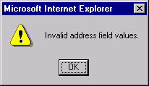
Invalid Ocean Region | If an invalid ocean region is entered, such as BEST for an urgent message broadcast, the following dialog box will appear. The ocean region must be corrected to send the message.  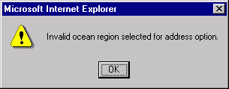
Lat/Long/Extensions fields blank | If a lat/long field or extensions/radius fields is left blank, the following dialog box will appear. Fields must be filled in to send the message.  